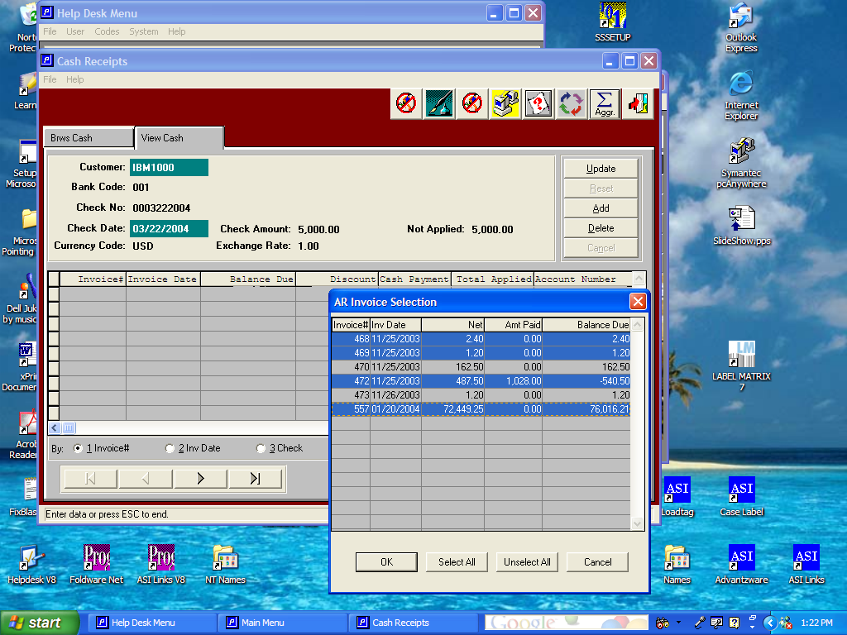

New Cash Receipts Logic as of March 22, 2004

Cash receipts now allow selecting invoices identical to Microsoft explorer or you may click the buttons at the bottom of the screen. The select all button will highlight all the invoices shown on the popup window. To eliminate a few invoices, simply press the CTRL key and click the appropriate invoices, which will deselect or un-highlight that invoice.

To select individual invoices, simply press the CTRL key and click the invoices paid, which will highlight those invoices. To pick a range of invoices, highlight the first invoice, then press the SHIFT key and click the last invoice number and the entire list will be highlighted.

For example, let’s assume I wanted to selecte all invoices except 470 and 473.
First, I would press the SHIFT key and highlight invoice 468, then I would press the SHIFT key and select invoice 557, which would then highlight all invoices. Next, I would press the CNTRL key and click on invoices 470 and 473 to unselect those invoices. Alternatively, I could press the SELECT ALL button, then press the CNTRL key to deselected invoices 470 and 473.

